

**Asset Practice Questions: Mathematics**

1. How many squares are there in the figure below?

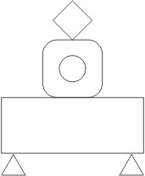

A. 0

B. 1

C. 2

D. 3

2. Romy is drawing a square.

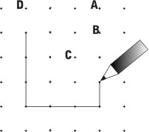

Which point will the completed square touch?

A. Point C

B. Point D

C. Point A

D. Point B

3. A triangle is turned as shown below.

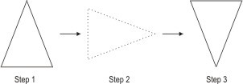

What is true about the shape formed in step 3?

A. It will be a triangle.

B. It will be a cone.

C. There is no name for the shape formed.

D. It will be a new shape that is NOT a triangle or a cone.

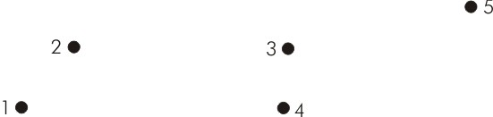4. Five dots are shown below

Which three dots can be joined with just one straight line?

A. 1, 2 and 3

B. 1, 3 and 5

C. 2, 4 and 5

D. 2, 3 and 5

5. How many straight lines are there in the figure shown below?



A. 2

B. 4

C. 5

D. 6

6. The eraser shown below is 1 unit long.

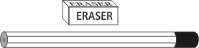

The length of the pencil can be estimated as _____

A. 2 units

B. 4 units C. 7 units D. 8 units

7. Hamid had a block of wood with a dot on one of its faces.

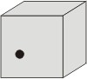

He put a dot on each of the other faces of this block. How many dots did he put?

A. 2

B. 5

C. 7

D. 8

8. Which of these is a square?

A. 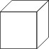 B. 

C. 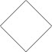 D. 

A. (A)

B. (B)

C. (C)

D. (D)

9. A pizza was divided into 4 equal pieces and Anand ate one of the pieces.

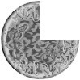

If Anand eats ONE MORE piece, what part of the pizza will remain?

A. 1/4

B. 1/2

C. 3/4

D. No part will remain.

10. What fraction of the figure below is shaded?

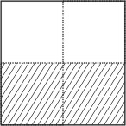

A. 1/2

B. 1/3

C. 2/2

D. 1/4

11. What fraction of the square is shaded?

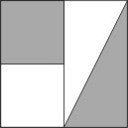

A. one

B. a quarter

C. two quarters

D. a quarter and a half

12. A small bowl contained some gems, 1/2 of which were red.



All the gems from this small bowl were put into an empty larger bowl. What fraction of the gems will be red in this larger bowl?

A. 1

B. 1/2

C. 1/4

D. 1/8